11 Illustrate the concept of multithreading using a C program.
#include <stdio.h>
#include <pthread.h>

void *display(void *arg) {
printf("Hello from Thread!\n");
return NULL;
}

int main() {
pthread_t t;

pthread_create(&t, NULL, display, NULL); // Create thread
pthread_join(t, NULL); // Wait for thread

printf("Thread execution completed.\n");

return 0;
}

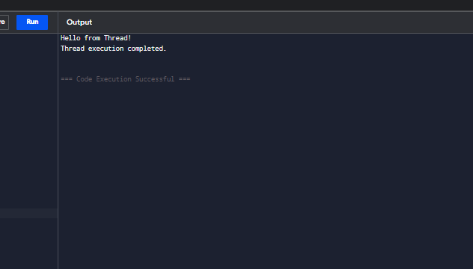

12 Design a C program to simulate the concept of Dining-Philosophers problem

#include <stdio.h>

int main() {
int i;

for(i = 1; i <= 5; i++) {
printf("Philosopher %d is Thinking\n", i);
printf("Philosopher %d takes Fork %d and Fork %d\n", i, i, (i % 5) + 1);
printf("Philosopher %d is Eating\n", i);
printf("Philosopher %d puts down Fork %d and Fork %d\n\n", i, i, (i % 5) + 1);
}

return 0;
}

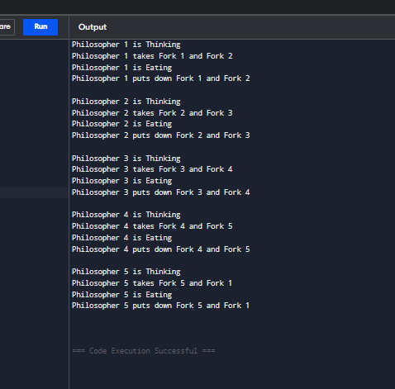

17. Illustrate the deadlock avoidance concept by simulating Banker’s algorithm with
C.
#include <stdio.h>
int main() {
int n, m, i, j, k;
printf("Enter number of processes: ");
scanf("%d", &n);
printf("Enter number of resource types: ");
scanf("%d", &m);
int alloc[n][m], max[n][m], need[n][m];
int avail[m];
int finish[n], safeSeq[n];
printf("\nEnter Allocation Matrix:\n");
for(i = 0; i < n; i++) {
for(j = 0; j < m; j++) {
scanf("%d", &alloc[i][j]);
}
}
printf("\nEnter Maximum Matrix:\n");
for(i = 0; i < n; i++) {
for(j = 0; j < m; j++) {
scanf("%d", &max[i][j]);
}
}
printf("\nEnter Available Resources:\n");
for(i = 0; i < m; i++) {
scanf("%d", &avail[i]);
}
for(i = 0; i < n; i++) {
for(j = 0; j < m; j++) {
need[i][j] = max[i][j] - alloc[i][j];
}
}
for(i = 0; i < n; i++)
finish[i] = 0;
int count = 0;
while(count < n) {
int found = 0;
for(i = 0; i < n; i++) {
if(finish[i] == 0) {
int possible = 1;
for(j = 0; j < m; j++) {
if(need[i][j] > avail[j]) {
possible = 0;
break;
}
}
if(possible) {
for(k = 0; k < m; k++)
avail[k] += alloc[i][k];
safeSeq[count++] = i;
finish[i] = 1;
found = 1;
}
}
}
if(found == 0) {
printf("\nSystem is NOT in a Safe State.\n");
return 0;
}
}
printf("\nSystem is in Safe State.\n");
printf("Safe Sequence: ");
for(i = 0; i < n; i++) {
printf("P%d", safeSeq[i]);
if(i != n - 1)
printf(" -> ");
}
printf("\n");
return 0;
}
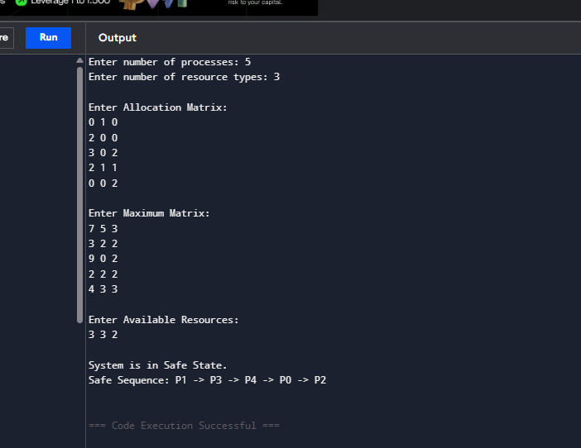

18. Construct a C program to simulate producer-consumer problem using
semaphores.
#include <stdio.h>
int mutex = 1;
int full = 0;
int empty = 3, x = 0;
int wait(int s)
{
return (--s);
}
int signal(int s)
{
return (++s);
}
int main()
{
int choice;
while (1)
{
printf("\n1. Producer");
printf("\n2. Consumer");
printf("\n3. Exit");
printf("\nEnter your choice: ");
scanf("%d", &choice);
switch (choice){
case 1:
if ((mutex == 1) && (empty != 0))
{
mutex = wait(mutex);
full = signal(full);
empty = wait(empty);
x++;
printf("Producer produces item %d\n", x);
mutex = signal(mutex);
}
else
{
printf("Buffer is Full!\n");
}
break;
case 2:
if ((mutex == 1) && (full != 0))
{
mutex = wait(mutex);
full = wait(full);
empty = signal(empty);
printf("Consumer consumes item %d\n", x);
x--;
mutex = signal(mutex);
}
else
{
printf("Buffer is Empty!\n");
}
break;
case 3:
return 0;
default:
printf("Invalid Choice!\n");
}
}
return 0;
}
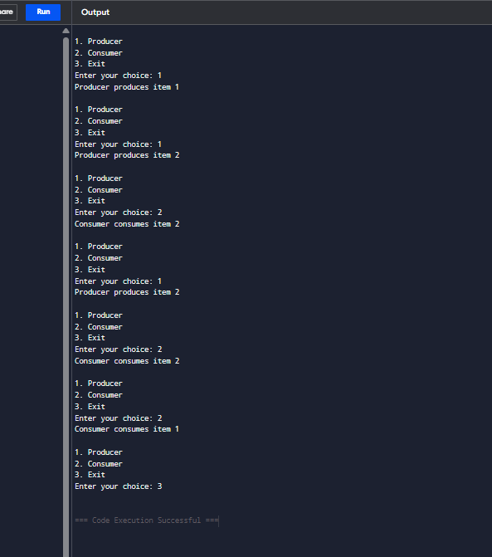

19. Design a C program to implement process synchronization using mutex locks.
#include <stdio.h>
#include <pthread.h>
int counter = 0;
pthread_mutex_t lock;
void *increment(void *arg)
{
int i;
pthread_mutex_lock(&lock);
for(i = 1; i <= 5; i++)
{
counter++;
printf("Counter = %d\n", counter);
}
pthread_mutex_unlock(&lock);
return NULL;
}
int main()
{
pthread_t t1, t2;
pthread_mutex_init(&lock, NULL);
pthread_create(&t1, NULL, increment, NULL);
pthread_create(&t2, NULL, increment, NULL);
pthread_join(t1, NULL);
pthread_join(t2, NULL);
pthread_mutex_destroy(&lock);
printf("Final Counter = %d\n", counter);
return 0;
}
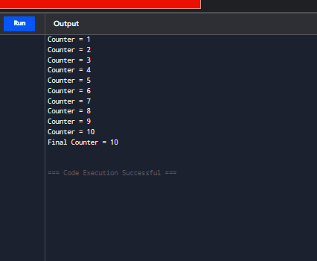

20. Construct a C program to simulate Reader-Writer problem using Semaphores.
#include <stdio.h>
int mutex = 1, wrt = 1;
int readcount = 0;
int wait(int s)
{
return --s;
}
int signal(int s)
{
return ++s;
}
void reader(int id)
{
mutex = wait(mutex);
readcount++;
if (readcount == 1)
wrt = wait(wrt);
mutex = signal(mutex);
printf("Reader %d is reading\n", id);
mutex = wait(mutex);
readcount--;
if (readcount == 0)
wrt = signal(wrt);
mutex = signal(mutex);
}
void writer(int id)
{
wrt = wait(wrt);
printf("Writer %d is writing\n", id);
wrt = signal(wrt);
}
int main()
{
int choice, id;
while (1)
{
printf("\n1. Reader");
printf("\n2. Writer");
printf("\n3. Exit");
printf("\nEnter your choice: ");
scanf("%d", &choice);
switch (choice)
{
case 1:
printf("Enter Reader ID: ");
scanf("%d", &id);
reader(id);
break;
case 2:
printf("Enter Writer ID: ");
scanf("%d", &id);
writer(id);
break;
case 3:
return 0;
default:
printf("Invalid Choice!\n");
}
}
return 0;
}
